|  |  |
| --- | --- |
| Type: | Corporate |
| Division(s): | All |
| Hardware:  Operating System | Office Laptop/ PC  All |

To create server CI in CMDB manually

# Addresses the Following Symptom(s):

* Request for select a Business App or Service record for INC/Change Request/Problem Request in ServiceNow
* Server is not auto-discoverable
* Storage servers/ Appliances

# Does NOT address the Following Symptom(s):

* 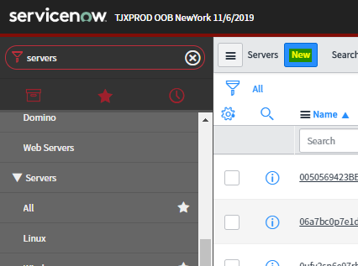Request to update a server
* Server is auto-discoverable

# Troubleshooting:

1. Check the server existence in CMDB.

If server not found:

1. Open the servers page under ‘Configuration’—‘All’ and click on ‘New’.
2. Fill in the form with all the information from the user.

[Note: Select the class as per the server classification. (E.g. Windows server, Linux server, Storage server, etc.)]

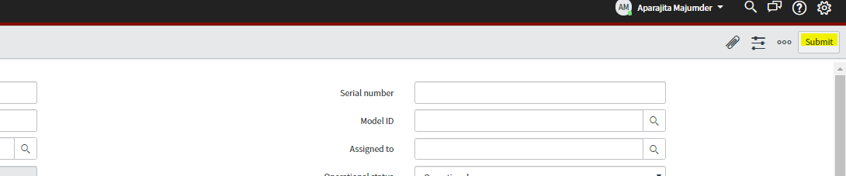

1. Click on ‘Submit’.

If **[server not created]**, assign ticket to [**CS-CMDB-L2**].

Legacy Checklist & Keywords:   
[Category]>[Subcategory]>[Symptom]

Carl Lothian v1.0

1.0 Full rewrite